

OATS(Oracle Application Testing Suite) Frame Work Design

Version: 1.0
Updated: 09/11/2019
Author: IBM Global Services

Revision History
Revision Number | Date | Revision Author | Description
0.1 to 1.0 | 09/11/2013 | Sujit K Swain | Changes will be not tracked.

Distribution
Name | Title | Sign-off Required

Table of Contents
1. Purpose 4
2. Intended Audience 4
3. Overview / Executive Summary 4
4. Test Effort Summary 6
4.1 Test Case Execution Summary 6
4.2 Test Execution Summary by TACs 6
5. Defect/Issue Summary 6
6. Analysis and Conclusion 8
Appendix A – Lesson Learnt 9
Appendix B – Open / Deferred Issues and Defects 9
Appendix C – Open / Deferred Issues and Defects 12

Purpose
Testing frameworks are an essential part of any successful automated testing process. They can reduce maintenance costs and testing efforts and will provide a higher return on investment (ROI) for QA teams looking to optimize their testing processes.
Framework is a guide line or set up rules which is everyone needs to follow to get the effective results.

- Goals and Objectives of Software Test Automation FrameWork
Automation Testing FrameWork is a way to organize the code so that it can be
- Reusable
- Scalable
- Maintainable
- Understandable
- Workable

Software Test Automation Objective
- To reduce Testing Cost and Time.
- To reduce Redundancy.
- To speed up the Testing Process.
- To help improve Quality.
- To improve Test coverage.
- To reduce Manual Intervention.

Intended Audience
The target audience of the document includes all parties interested in or involved in testing the Maaden account.
The following have been identified as the audience for this document.
- IT Test Team
- Project Managers
- Business Analysts
- Senior Leadership
- Developers
- Data Architects
- Systems Architects

Manual Testing Vs Automation Testing
Manual Testing
- Time consuming
- Low reliability
- Human resources
- Inconsistent
Automated Testing
  - Speed
  - Repeatability
  - Coverage
  - Reliability
  - Reusability

FrameWork Setup (DDT)

OATS framework (DDT- Data Driven Testing) has been set up in the windows server.
A set of guidelines like coding standards, test- data handling, object repository treatment, which when followed during automation scripting produce beneficial outcomes like increase code re-usages, higher portability, reduce script maintenance cost etc.

- Data Driven framework are used where automation testing relay on number of input test data.
- It can be removing the hardcoded data from the script and replace with the input test data; hence, they need to pull from external data sources.
- The data source can be CSV, excel, xml and SQL DataBase Table.
- Data Driven FrameWork will have code to pull the test data from any of the data source, which can be then used to populate data on application UI during data entry operations.
FrameWork Structure
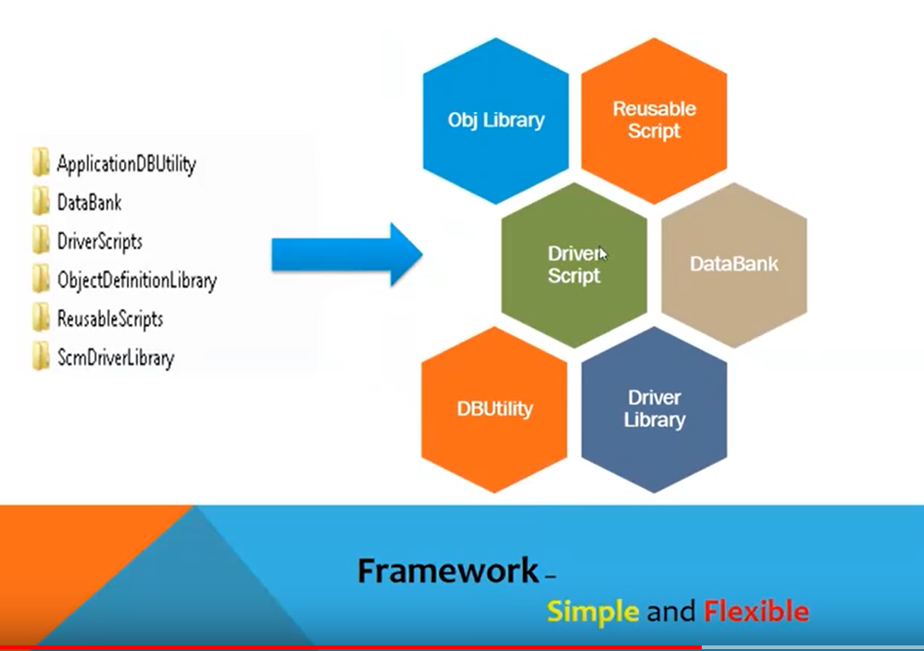

ApplicationDBUtility – This folder will have the library function which is related to the data base. Bacically it deals with the data base activity.
DataBank – As the name suggest, this folder can contains the test data only. It can be CSV file or excel file where you can store the test data which needs to supply to the script during execution.
DriverScripts- As per the requirement, it can call the multiple resuable script and run in integration manner.
ObjectDefinationLibrary-
ResuableScript
SCMDriverLibrary-

Pictorial diagram – How it works
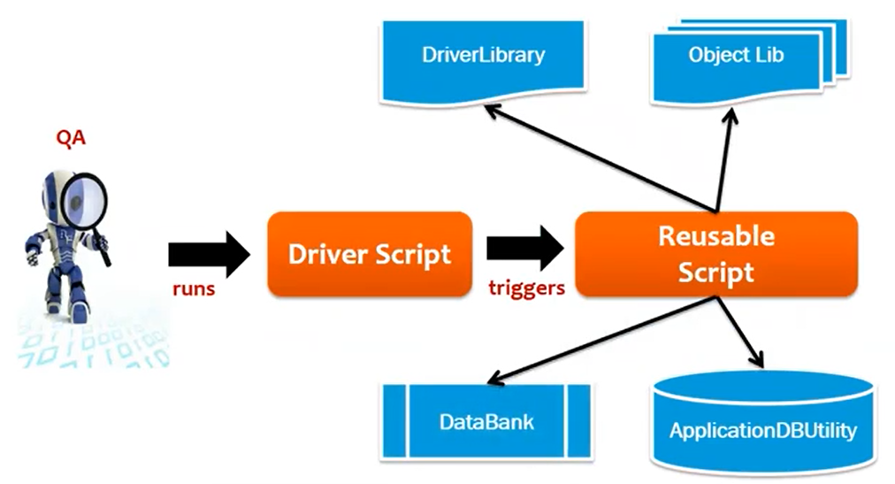

Overview / Executive Summary
This Test Report of the Project Solid Project provides insight into actual testing achievements.
The flow of the system Testing was as follows:
3.2 Work-flow for System Test

Document Test Requirement

Test Plan
Execute Test Cases

Test Cases

Defect and Issue
Logging
View Reports & Dashboard

Workflow Notes:

- Test Requirements– Cycles started with requirement gathering. As per the SOW development of Automated Test scripts (up to 20 scripts/ month) as part of the Regression Testing using OATS Tool. So as manual testing tester is not present in the project, it will be the responsibility of the developer to provide the scenario details every month.
- Test Plan and Test Cases- we need to prepare the test plan along with the identified scenario once receive the requirement.
- Test Execute- Prepare the automation script for each scenario and execute the same in this phase
- Defect and issue logging – If any issue and defect found during the execution, logging the defect in the tool.
- Report– After execution the test the report needs to be documented as per evidence.
- Pre UAT Cycle started approximately 08/19/2013 through 09/06/2013.

Test case Execution Goals:
- Pre UAT Cycle – 20 Total Test cases Planned for Execution

TAC Name | Total Test Cases Planned
AIS | 11
BAO | 16
CAMS | 16
Oracle | 20
SAP | 19
Test | 22

Test Effort Summary

4.1 Test Case Execution Summary

Start Date / End Date | Planned | Passed | Failed | Blocked
Aug-19 2013  Sep-06 2013 | 104 | 10 | 73 | 21

Besides the “Passed” and “Failed” status, a test case is marked as “Blocked” if it cannot be executed due to one of the following reasons:
- Components are not delivered and the function is not available.
- Defects were found that will be corrected in a future release.
- Test data is not available or test environment is not set up.
- There are functional defects that impair test case execution and completion.

4.2 Test Execution Summary by TACs
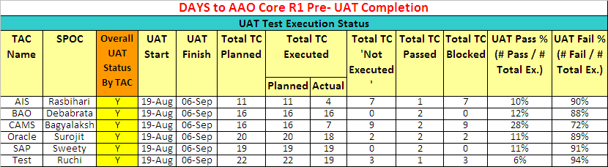

Defect/Issue Summary
A total of 97 issues/defects were reported during AAO Core Pre UAT out of which 21 defects/issues are identified as potential CRs.
“open” and/or “deferred” issues have been documented and presented to the Pre UAT users and Platform Development Team.
The table below illustrates the total defect/issue statistics by function area and severity:
Functional Area | 1-Critical | 2-High | 3-Medium | 4-Low | Total
Core to RTC |  | 2 | 4 |  | 6
Defect creation | 1 | 2 | 2 |  | 5
Deliverable Template | 2 | 4 | 7 |  | 13
Effort Estimation |  | 1 |  |  | 1
Issue |  | 1 | 3 | 1 | 5
Metrics | 1 |  |  |  | 1
Modify wbs | 3 | 2 | 2 |  | 7
Open Proj | 1 | 1 | 1 |  | 3
Project Management | 1 | 3 | 4 |  | 8
Report |  |  | 3 |  | 3
Resource Management |  | 1 | 2 |  | 3
RTC |  | 2 | 2 |  | 4
RTC to Core |  |  | 1 |  | 1
Task View List |  | 1 |  |  | 1
Work Request | 3 | 5 | 12 | 3 | 23
Work Scheduler | 5 | 2 | 5 | 1 | 13
Total | 17 | 27 | 48 | 5 | 97

Figure1: defect/issue statistics by function area and severity (Critical and High)
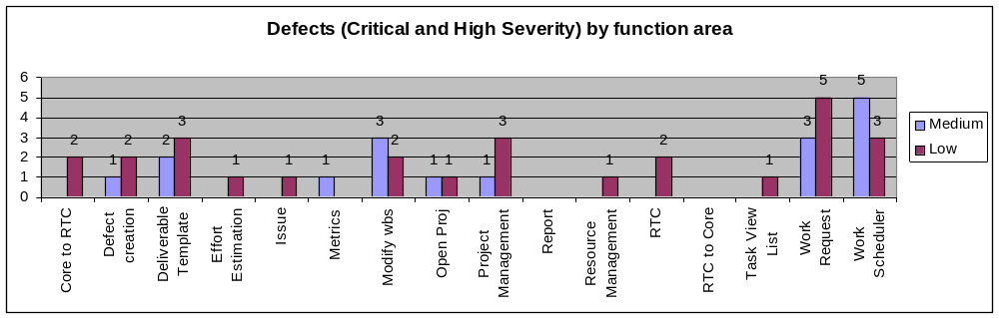
Figure2: defect/issue statistics by function area and severity (Medium and Low)
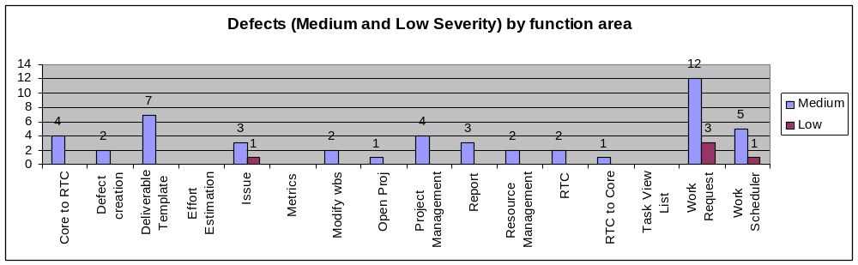

The table below illustrates the open defect/issue statistics by function area and severity:
Functional Area | 1-Critical | 2-High | 3-Medium | 4-Low | Total
Core to RTC |  | 1 | 3 |  | 4
Defect creation | 1 | 2 | 2 |  | 5
Deliverable Template | 1 | 3 | 6 |  | 10
Effort Estimation |  | 1 |  |  | 1
Issue |  | 1 | 3 | 1 | 5
Metrics | 1 |  |  |  | 1
Modify wbs | 3 | 2 | 2 |  | 7
Open Proj | 1 | 1 | 1 |  | 3
Project Management | 1 | 3 | 4 |  | 8
Report
Resource Management |  | 1 |  |  | 1
RTC |  | 1 | 2 |  | 3
RTC to Core |  |  | 1 |  | 1
Task View List |  | 1 |  |  | 1
Work Request |  | 2 | 5 | 2 | 9
Work Scheduler | 5 | 2 | 4 | 1 | 12
Total | 13 | 21 | 33 | 4 | 71

The table below illustrates the Change Request Defect statistics by function area and severity:
Functional Area | 1-Critical | 2-High | 3-Medium | 4-Low | Total
Core to RTC
Defect creation
Deliverable Template | 1 |  | 1 |  | 2
Effort Estimation
Issue
Metrics
Modify wbs
Open Proj
Project Management
Report |  |  | 3 |  | 3
Resource Management |  |  | 1 |  | 1
RTC |  | 1 |  |  | 1
RTC to Core
Task View List
Work Request | 3 | 3 | 6 |  | 12
Work Scheduler |  | 1 | 1 |  | 1
Total | 4 | 5 | 12 |  | 21

The table below illustrates the “Closed/Rejected” defect/issue statistics by function area and severity:
Functional Area | 1-Critical | 2-High | 3-Medium | 4-Low | Total
Core to RTC |  | 1 |  |  | 1
Defect creation
Deliverable Template
Effort Estimation
Issue
Metrics
Modify wbs
Open Proj
Project Management
Resource Management |  |  | 1 |  | 1
RTC
Task View List
Work Request |  |  | 2 | 1 | 3
Work Scheduler
RTC to Core
Report
Total |  | 1 | 3 | 1 | 5

Analysis and Conclusion
Upon conclusion of AAO Core Pre UAT all defects/issues were recorded. These records can be found in the RTC.
https://rcc-pok-idg-2642.cloud9.ibm.com:9445/ccm/web/projects/AAO%20Core%20Development%20Project%20Area#action=com.ibm.team.workitem.runSavedQuery&id=_OZwZgAMIEeOZpclA1a0nFg

Appendix A – Lesson Learnt

What process/practice worked well and should be repeated for future testing efforts?
- Testing performed by a dedicated test team from each TAC brought objective views and quality assurance focus.
- This was a guided Pre UAT with pre defined test cases uploaded in RQM. This helped us to get early feedbacks on the system and all the observations are captured in RTC.

What process/practice needs improvement?

- Ensure UAT Test cases are written based on the pre defined template provided by the platform development team. This will reduce the test case upload time to RQM.
- We need to ensure the UAT test cases are not too big. This is making the traceability very difficult.
- Platform development QA team needs one week to review the test cases provided by TACs. So we need to allocate total two weeks for QA review, rework and upload test cases to RQM.
- One week prior to UAT we need to upload master data to the UAT DB and access to the systems needs to be tested by the users to avoid any challenge during UAT.

Appendix B – Open / Deferred Issues, Defects and CRs
Severity | Defect ID | Summary
Critical | 6315 | WR/Sub WBS edit should be locked for download when one resource has already downloaded it for edit
Critical | 6308 | The work scheduler didnot function as expected - The Work-request was not assigned to resources
Critical | 6304 | SAP Deliverable seen under BAO TAC
Critical | 6303 | Unused Project ID on UAT Portal shows already occupied
Critical | 6293 | No China resource has got assigned after Invoke Work Scheduler
Critical | 6273 | Unable to edit Deliverable WBS
Critical | 6262 | Failing Test Case "SAP_TAC_TC_metric_generation_20" when executing Test Execution Record "SAP_TAC_TC_metric_generation_20_Sweety"
Critical | 6256 | UI for editing deliverables
Critical | 6252 | Issue, Defect and WPI not available for tracking
Critical | 6247 | CAMS TAC- Work request failing while sending deliverables to RTC
Critical | 6244 | Existing UI for deliverable creation
Critical | 6242 | Work Scheduler assignment should assign only the deliverables added by the user
Critical | 6227 | Workpacket Start date is other than the dates given in the deliverable template
Critical | 6158 | Different Workpacket assigned to same member at same time
Critical | 6023 | Deliverable WBS download from AAO Core Portal is erroneous
Critical | 6014 | Planned effort value in task changes when compared with original in OpenProj xml files
Critical | 6013 | Work Request creation in AAO Core - should allow multi TAC, multi service and multi location
High | 6301 | Defect, WPI and Issue templates should be complaint with the corresponding OPAL templates
High | 6286 | User does not have option to check the deliverables association with its parent WorkRequest/Sub WorkRequest in RTC
High | 6282 | No option for the user to remove/untag the deliverables from a WorkRequest/Sub WorkRequest
High | 6279 | How to log change requests
High | 6277 | The WS should assign an owner to the Deliverable
High | 6266 | Duration given in Deliverable template and duration seen while downloading Deliverable WBS is different
High | 6260 | Issues not reflecting into RTC
High | 6259 | Duplicate Work Request
High | 6255 | Deliverable template addition UI - all 5 complexity values are not available - only low, medium n high are available right now
High | 6251 | Missing Attributes in Deliverable and Task
High | 6246 | Deliverables already assigned should not be available in WR/Sub WR WBS edit
High | 6245 | Work Scheduler should only assign deliverables in a particular state
High | 6243 | Workpackets creation in AAO Core/RTC under deliverables
High | 6238 | Effort value gets changed while assigning a single Task to many practitioners
High | 6236 | Error while sending the Deliverables to RTC
High | 6234 | Failing Test Case "SAP_TAC_TC_work_request_wbs_edit_10" when executing Test Execution Record "SAP_TAC_TC_work_request_wbs_edit_10_Sweety"
High | 6229 | Not able to add Deliverable to WR while modifying workrequests
High | 6224 | No deliverable is being shown in a WR
High | 6223 | AAOWorkRequestPortlet and AAOWBSPortlet should be linked
High | 6220 | Deliverable template without Review and Rework tasks or MANDATORY tasks should not be allowed to be uploaded in AAO Core
High | 6219 | Option to add WPI and Defect should only be available in "Review" tasks
High | 6036 | Task Summary, parent deliverable, parent WR and planned date details not available in AAOTaskListPortlet
High | 6035 | Location attribute for Work Request creation
High | 6031 | Changes going away while uploading and downloading the WR WBS
High | 6021 | Failing Test Case "SAP_TAC_resource_calender_upload_03" when executing Test Execution Record "SAP_TAC_resource_calender_upload_03_Sweety"
High | 6012 | Unable to upload deliverable template with same role from multiple services
Low | 6258 | Work Scheduler should not take the dates from the deliverable templates but instead should take only from the Workrequest
Low | 6278 | Name of the xml file when we download should have the name of the WR or Sub-WR
Low | 6239 | Not able to see the Issues until we move to another WR and come back
Low | 6221 | Wrong Message displayed on the AAOWorkRequest Portet

Appendix C – Open / Deferred Issues and Defects

The test case results can be obtained from RQM from the following link:
https://rcc-pok-idg-2642.cloud9.ibm.com:9445/qm/web/console/RQM%20for%20CLM%20%28Quality%20Management%29#action=com.ibm.rqm.planning.home.actionDispatcher&subAction=viewTestCases&updateAction=clear-filter-selection

Sample Report Snapshot:
